**DAILY ONLINE ACTIVITIES SUMMARY**

|  |  |  |  |  |  |  |  |  |
| --- | --- | --- | --- | --- | --- | --- | --- | --- |
| **Date:** | **22 June 2020** | | | | | **Name:** | **Sana F Habib** | |
| **Sem & Sec** | **6th sem & B sec** | | | | | **USN:** | **4AL17CS081** | |
| **Online Test Summary** | | | | | | | | |
| **Subject** | | 9:20 am to 11:00 am - Programming in C++  11:00 am to 1:00pm | | | | | | |
| **Faculty** | | 1.Shilpa Y Gowda  2. Ankitha Shetty | | **Duration** | | | **4 hours** | |
| **Certification Course Summary** | | | | | | | | |
| **Course** | **Career Edge** | | | | | | | |
| **Certificate Provider** | | | **TCS** | | **Duration** | | | **20 days** |
| **Coding Challenges** | | | | | | | | |
| **Status: Executed** | | | | | | | | |
| **Uploaded the report in Github** | | | | | **YES** | | | |
| **If yes Repository name** | | | | | [**https://github.com/sanahabib2409199/Sana-F-H.git**](https://github.com/sanahabib2409199/Sana-F-H.git)  **(coding)** | | | |
| **Uploaded the report in slack** | | | | | **YES** | | | |
| Applications of python in DA and ML  (Dr .Mohideen  Badhusha) | | | | | [**https://github.com/sanahabib2409199/Python-Worshop.git**](https://github.com/sanahabib2409199/Python-Worshop.git) | | | |

Workshop Exercise:

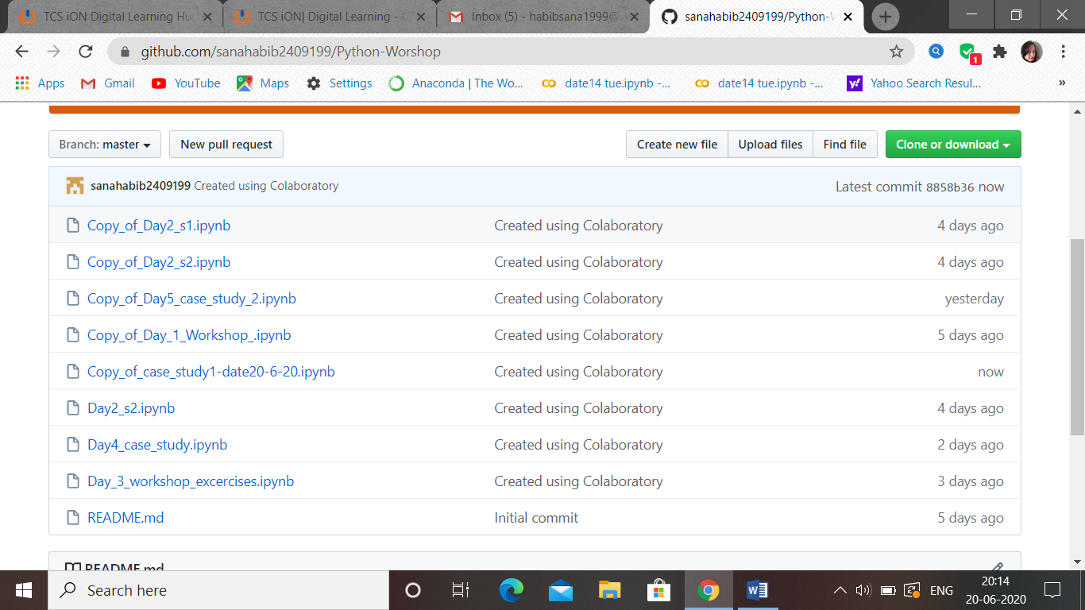

Certification Course Details: (Attach the snapshot and briefly write the report for the same)

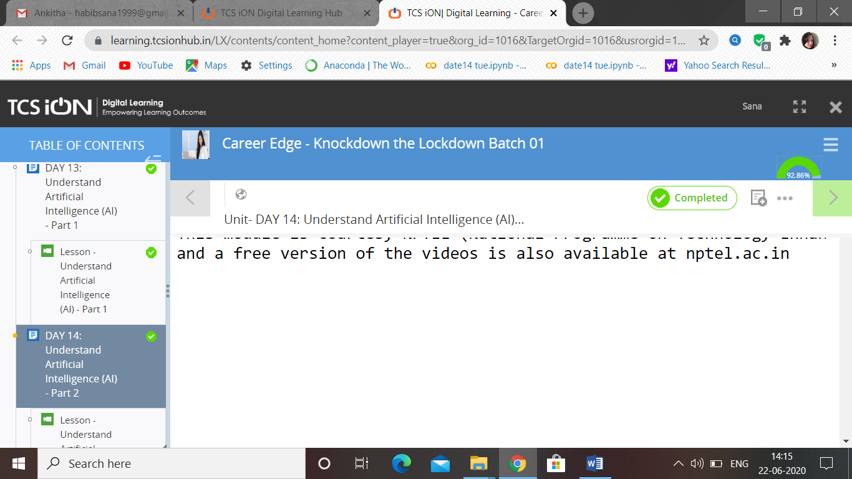

(22-06-2020)-Career Edge. TCS-Understanding accounting and fundamentals and foundational skills in IT, Understand artificial intelligence (AI)-part1 and part2.

### >>Programming in C++…

Quiz -Programming in C++:-

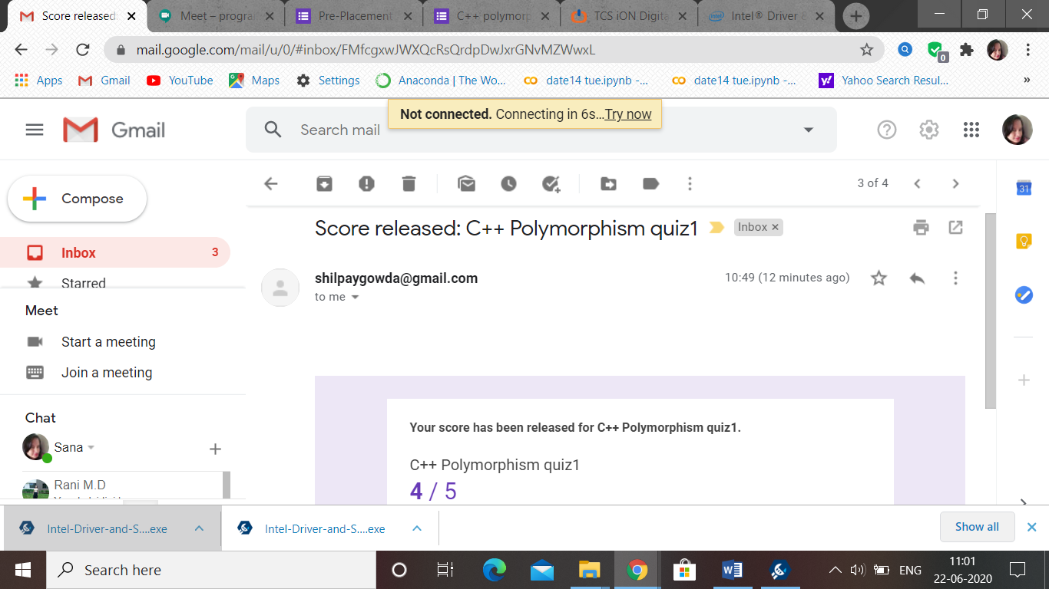

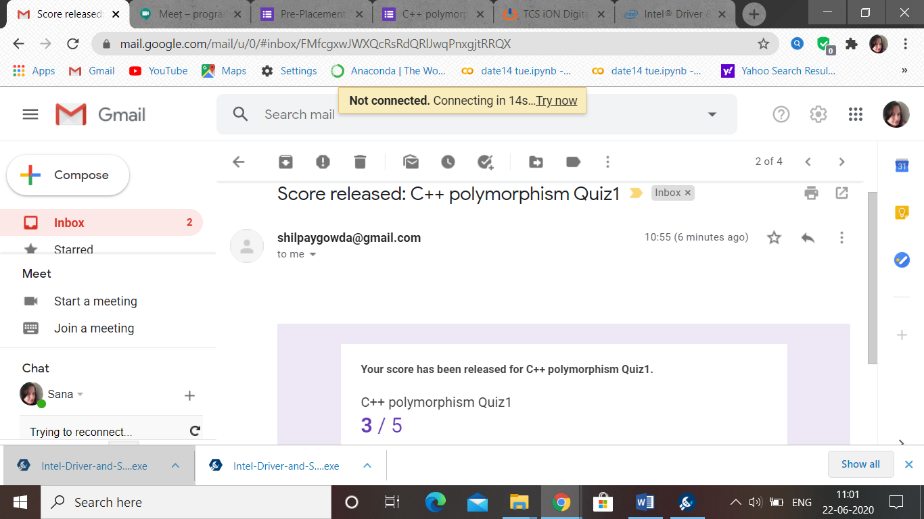

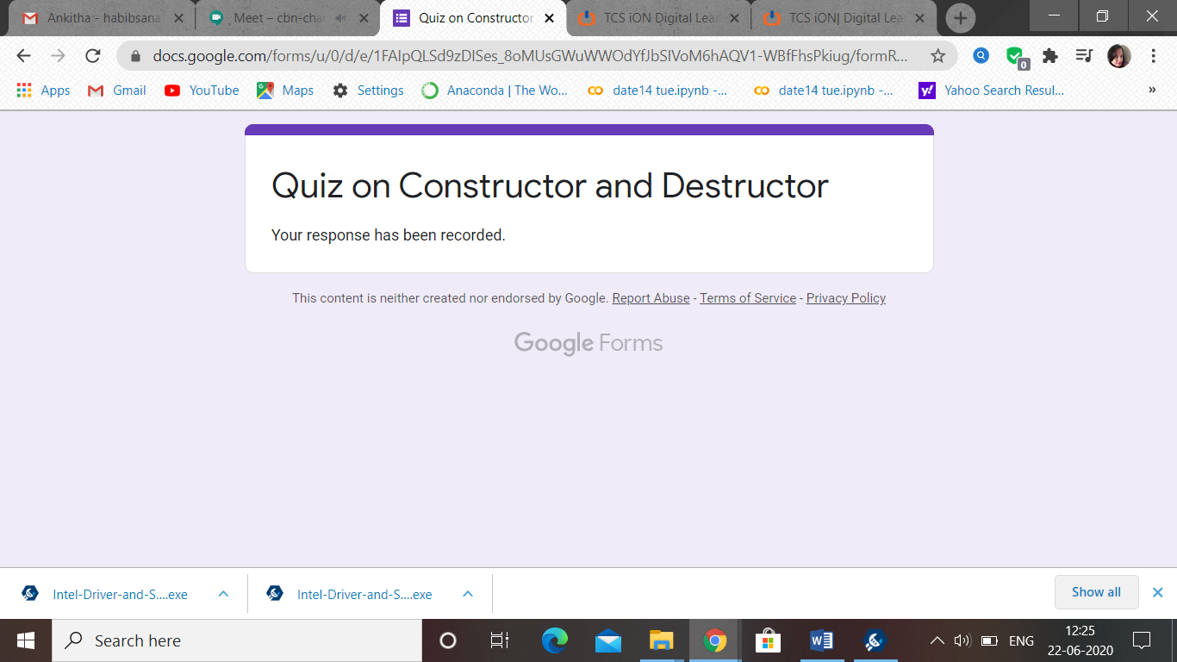

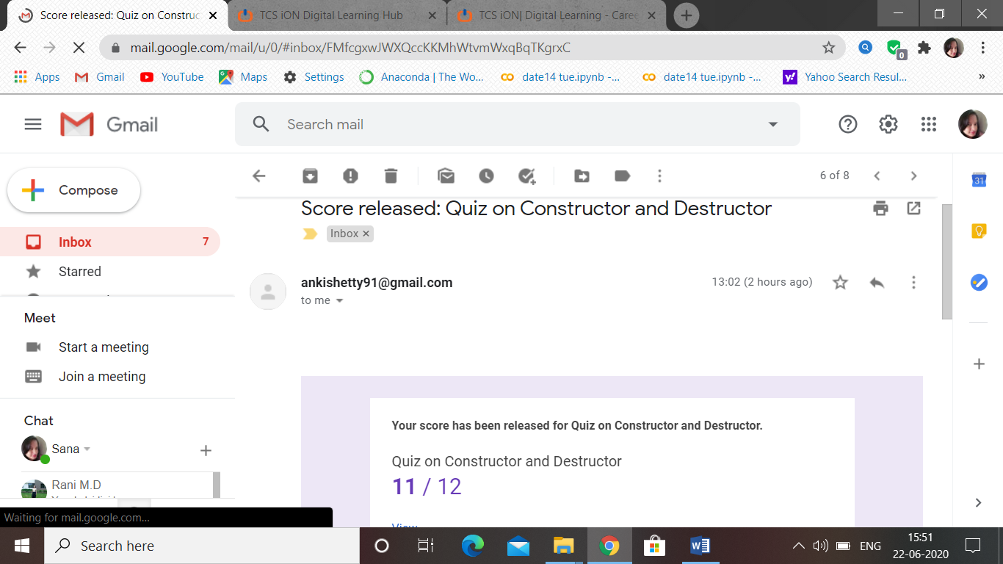

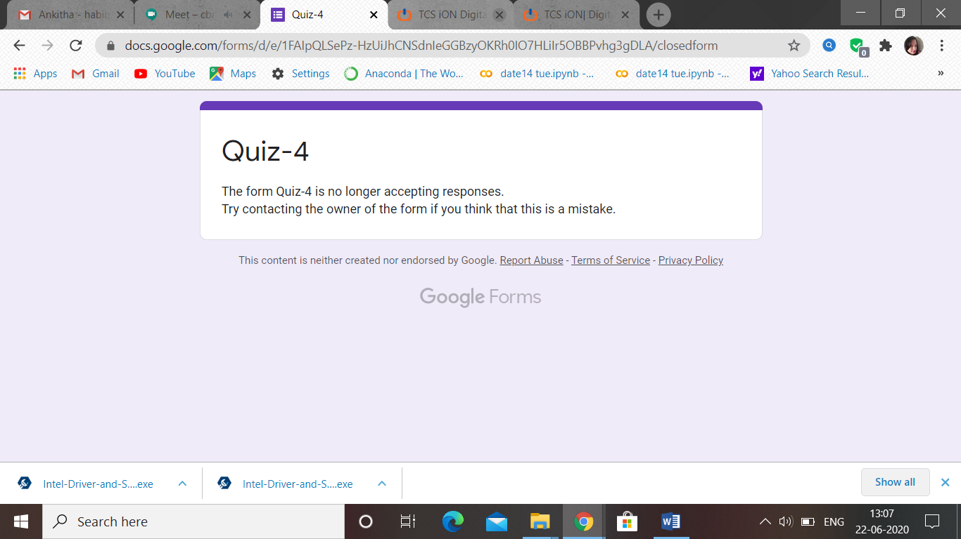

Coding Challenges Details: (Attach the snapshot and briefly write the report for the same)

Program 1

